Name: Aradhya Phutak

Github: Aradhyagh

Project: Reviews Analysis

**Aim:**

To extract actionable insights from Amazon customer reviews of the 'Good Knight Mosquito Repellent Liquid' product, with the objective of understanding customer sentiment, identifying areas for improvement, and informing data-driven business decisions.

**Executive Summary:**

This report analyzes Amazon customer reviews of Good Knight Mosquito Repellent Liquid to extract insights that inform product evaluation and improvement. The goal is to understand customer sentiment and identify common themes using data-driven techniques.

Reviews were web scraped and analyzed using pre-trained NLP models to extract sentiment and key insights. A Power BI dashboard was created to visualize trends and customer feedback interactively. Additionally, a sentiment classification model was developed using reviews from both Good Knight and competitor products to support future sentiment analysis tasks.

Findings reveal trends in customer satisfaction, including comments on product effectiveness, fragrance, and packaging. The report offers data-backed recommendations to enhance product quality and customer experience.

**Background Information:**

With the growing reliance on e-commerce platforms like Amazon, customer reviews have become a critical source of feedback for consumer products. These reviews offer unfiltered insights into user experiences, expectations, and areas of dissatisfaction. For products like Good Knight Mosquito Repellent Liquid, which serve a functional and health-related purpose, understanding customer sentiment is essential for maintaining product quality and brand trust.

**Relevance or Context:**

In a competitive market where customer perception directly impacts sales and loyalty, leveraging Natural Language Processing (NLP) and data visualization tools enables businesses to go beyond star ratings and understand the real voice of the customer. This analysis aligns with the increasing use of AI-driven methods in product development, marketing strategy, and customer experience management.

**Materials / Requirements:**

The following tools and libraries were utilized throughout the project to perform data extraction, analysis, modeling, and visualization:

1. **Python Environment**
   * Core programming language used for data scraping, preprocessing, NLP analysis, and model development.
2. **Web Scraping Tools**
   * BeautifulSoup: For parsing and extracting review content from Amazon webpages.
   * re (Regular Expressions): For pattern matching and cleaning textual data.
   * pandas: For organizing and manipulating the scraped data.
3. **Natural Language Processing (NLP) Components**
   * **Pre-trained NLP classes/models** for:
     + Aspect detection
     + Adjective detection
     + Aspect-based sentiment prediction
     + Named Entity Recognition (NER)
     + Empathy detection
     + Emotion extraction
     + Computed sentiment scoring   
       (apart from sentiments based on reviews)
     + General sentiment classification
4. **Machine Learning Tools**
   * Tokenizer: For converting text into numerical format.
   * Bag of Words (BoW): For feature extraction from text.
   * Stopwords Removal: To eliminate common words with low semantic value.
   * Sequential Models: For building and training the sentiment analysis classification model.
5. **Visualization Tool**
   * **Power BI**: For building interactive dashboards to visualize customer sentiment, trends, and thematic insights.

**Procedure / Methodology:**

The project was carried out in the following sequential steps:

1. **Data Collection**
   * Amazon product reviews for *Good Knight Mosquito Repellent Liquid* were scraped using BeautifulSoup and requests in Python.
   * Regular expressions (re) were used to clean and structure the raw HTML content.
   * The extracted reviews were stored and organized using pandas for further processing.
2. **Data Preprocessing**
   * Text data was cleaned by removing special characters, HTML tags, and stopwords.
   * Tokenization and lemmatization were applied to prepare the text for NLP tasks.
3. **NLP Analysis**
   * Pre-trained NLP models and classes were used to perform:
     + **Aspect Detection**: Identification of product-related features (e.g., smell, effectiveness).
     + **Adjective Detection**: Extracting descriptive words associated with aspects.
     + **Aspect-Based Sentiment Prediction**: Determining sentiment polarity for specific aspects.
     + **NER (Named Entity Recognition)**: Extracting named entities for deeper context.
     + **Empathy Detection & Emotion Extraction**: Measuring emotional tones in reviews.
     + **Sentiment Scoring**: Calculating overall sentiment using NLP-based scoring techniques.
     + **General Sentiment Analysis**: Classifying reviews as positive, negative, or neutral.
4. **Visualization**
   * Power BI was used to build an interactive dashboard that visualizes:
     + Sentiment distribution
     + Frequent keywords and topics
     + Aspect-wise sentiment trends
     + Emotion and empathy patterns
   * The dashboard enables easy exploration of customer feedback for various stakeholders.
5. **Model Development**
   * A sentiment classification model was trained using a dataset of reviews from *Good Knight* and competing mosquito repellent products.
   * Techniques used included Bag of Words, Tokenizer, and Sequential neural networks.
   * The model was designed to predict sentiment labels for new or incoming reviews.

**Power BI Dashboard Insights:**

**Slide 1: Data Demographics – Overview & Rating Trends**

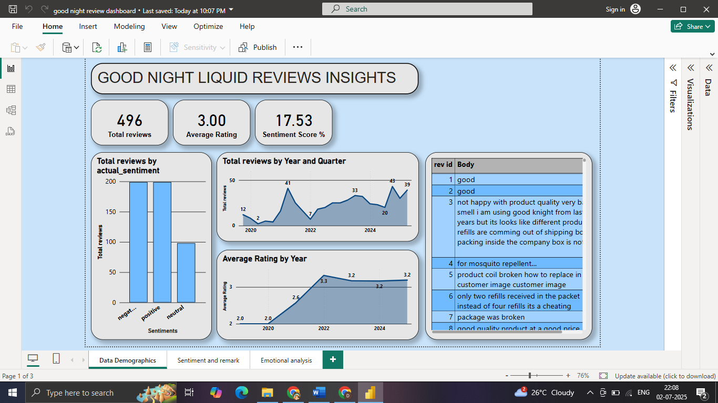

**Note:**

* The rating distribution and average (3.0) are **uniform by design**, not reflective of natural consumer behavior.
* Sentiment analysis and rating trends should thus focus on **textual insights** and **temporal patterns**, not the numerical rating average.

**Observations:**

* **Total Reviews:** 496 reviews analyzed (near total 500).
* **Sentiment Distribution:** Even split between **positive and negative**, fewer neutral reviews (~90).
* **Quarterly Review Trends:** Sharp spike in Q1 2022 (41 reviews) and again in 2024 Q1 (43 reviews).
* **Average Rating Trend (by Year):** Ratings rose from 2.0 (2020) to 3.3 (2022), then plateaued.

**Slide 2: Aspect & Adjective Analysis (All Reviews)**

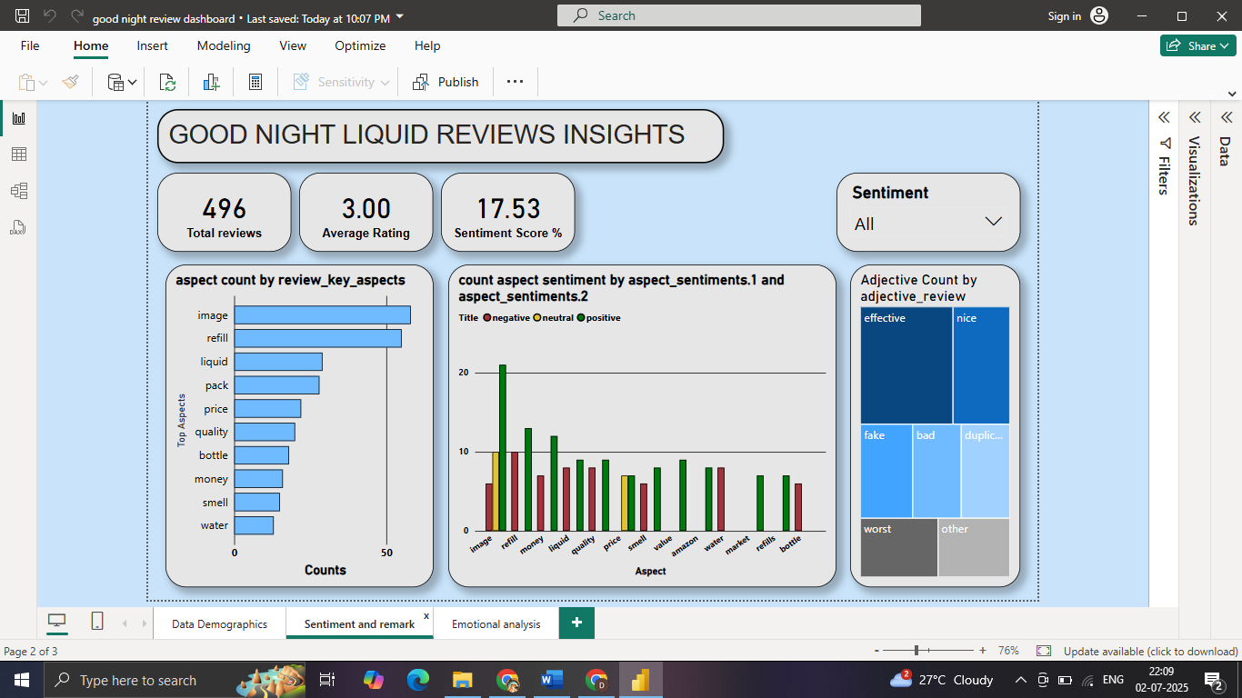

**Observations:**

* **Top Aspects:** *Image*, *Refill*, *Liquid*, *Pack*, *Price*, *Quality*
* **Aspect Sentiment Polarity:**
  + *Image* & *Refill* → mixed, leaning negative.
  + *Quality*, *Smell* → mostly negative.
* **Adjective TreeMap:**
  + Positive: *Effective*, *Nice*
  + Negative: *Fake*, *Bad*, *Worst*, *Duplicate*

**Actionables:**

* Investigate **issues around refills and packaging clarity**.
* Combat **‘fake’ and ‘duplicate’ perceptions**—likely linked to counterfeit or poor delivery.
* Redesign product image and labeling to **match performance expectations**.

**Slide 2: Negative Sentiment Filter – Root Cause Drill Down**

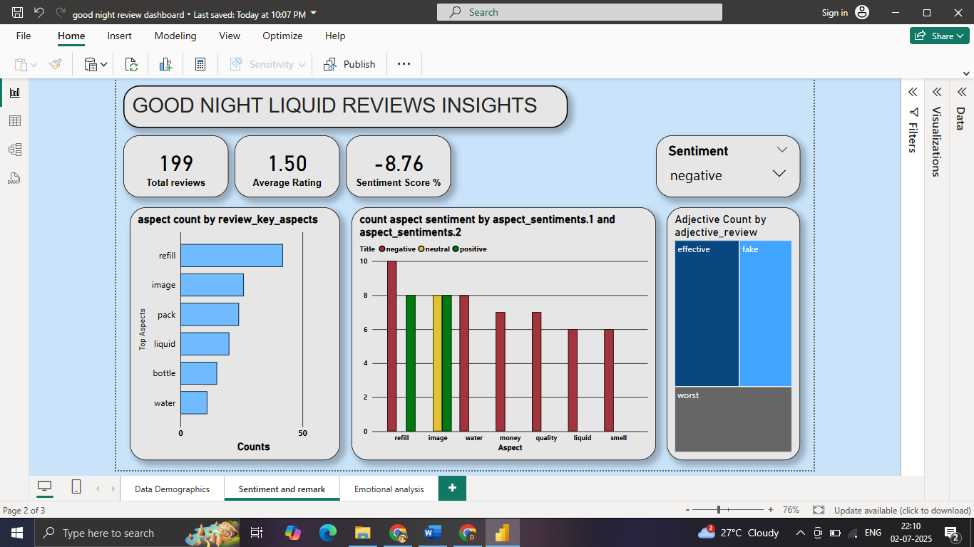

**Observations:**

* **Total Negative Reviews:** 199 (intentionally sampled)
* **Sentiment Score:** -8.76% shows strong discontent.
* **Negative Aspects:** *Refill*, *Image*, *Pack*, *Liquid* are top complaints.
* **Adjectives:** *Fake*, *Worst*, *Effective* (possibly used sarcastically).

**Actionables:**

* Launch **product usage validation program** to counter fake/duplicate product concerns.
* Prioritize **refill usability improvements** and strengthen **consumer education**.
* Train customer support to handle these **core complaints empathetically and swiftly**.

**Slide 3: Emotional Analysis – Empathy and First Emotion**

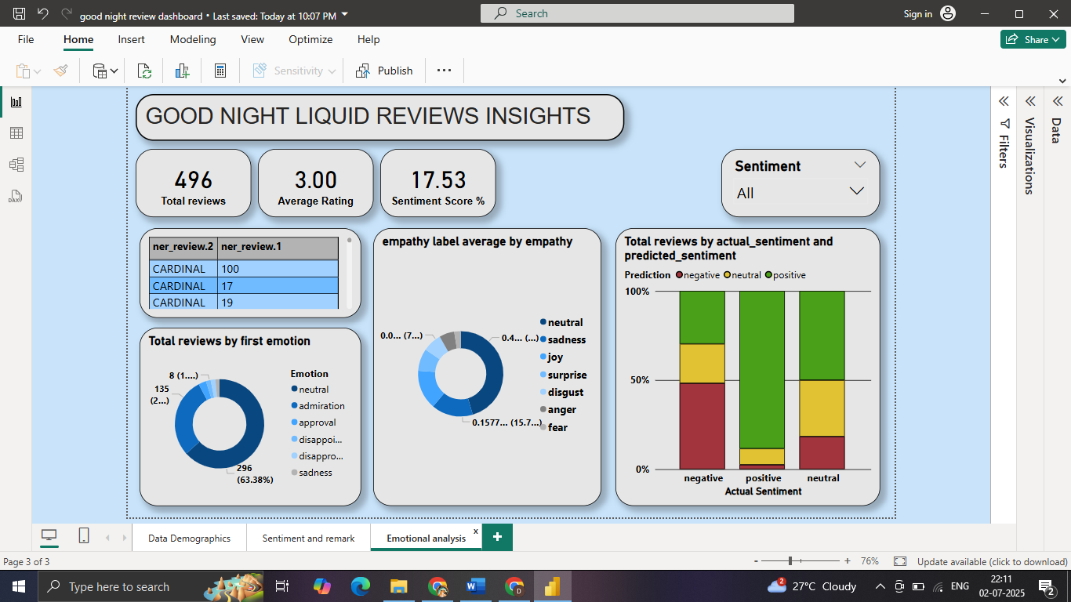

**Observations:**

* **Dominant First Emotion:** *Neutral* (~63%), followed by *Disappointment* and *Sadness*.
* **Empathy Score:** Low-to-moderate (avg ~0.15), indicating factual or restrained emotional tone.
* **Actual vs Predicted Sentiment Match:** Reasonable alignment but some misclassification of neutral reviews.

**Actionables:**

* Refine **sentiment and empathy models** to better capture nuanced negative tones like sarcasm or disapproval.
* Build **emotional storytelling** into brand campaigns to increase engagement.
* Use high-emotion feedback for **improving automated and human response training**.

**Overall Strategic Plan (With Sampling Correction in Mind)**

| **Area** | **Actionable** | **Note** |
| --- | --- | --- |
| **Product & Refill** | Redesign refill mechanism; address leakage/fit issues | Key driver of negative reviews |
| **Trust & Authenticity** | Tackle “fake” claims with packaging security & awareness | Build consumer confidence |
| **Customer Service** | Empathy training for agents | Match disappointment-based emotions |
| **Brand Communication** | Fix image mismatch between pack and product | Align expectations vs reality |
| **Analytics & Research** | Rely more on **textual sentiment** than ratings | Due to equal star sampling |